Question 1 [5 Points]
Consider the following NFA.
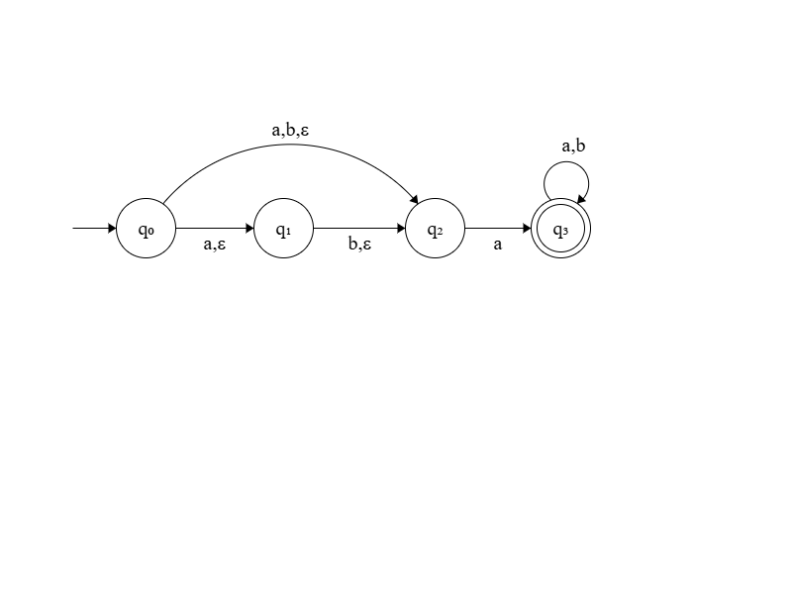
Now solve the following problems. Note that you do not need to convert the given NFA into its equivalent DFA in order to answer the following questions.
- If you convert the given NFA into an equivalent DFA using the subset construction method, what is the maximum number of states the DFA can have? (1 Point)
Answer:
- Write the ε-closure of state q1 in the given NFA. (1 Point)
Answer:
- What is δ({q1, q3}, b) in the given NFA? Write all the states.
(1 Point)
Answer:
- What will be the start state of the equivalent DFA during the conversion? (2 Points)
Answer:

Question 2 [10 Points]
Convert the following Regular Expression into an equivalent NFA using the procedure shown in class.
((0|10)∗|(1|01)∗)10

[Answer in the next page]

